Superhetrodyne reciever

EE421 – Experiment 10 Lab Report

by

Aman Khatri, kaman

Experiment performed on 28th April 2012

Report submitted on 29th April 2012

EE 421 - Communications

Department of Electrical and Computer Engineering

The University of Alabama at Birmingham

Lab Team:
Aman Khatri

Abstract
In communications, a message is transmitted through open space by electromagnetic waves. These electromagnetic waves, also known as modulating signal, generally contain important messages. Since, these waves travel great deal of distances they need a carrier electromagnetic waves on which they can be modulated. A communication system, for example a radio transmits a modulated signal. The modulated carrier signal then travels down the transmission medium and reaches at the input of radio receiver. The signal thus received is very weak. Inside the receiver this weak signal is amplified in Radio Frequency (RF) amplifier stage of the radio receiver. Also, since the received signal contains a lot of noise at adjacent frequencies, the next job of the radio receiver comes to reject this noise. Finally the modulated carrier signal (RF signal) is demodulated to get back the original message, which is very weak. This signal is then amplified to get the audible audio. In this lab we would explore a special type of such receiver called Superheterodyne receiver.

Table of Contents

Abstract i
Introduction 1
Theory 1
MethodS 1
Experimental Procedure 1
Equipment List 1
Results 3
Conclusions 3
References 6

Introduction

The purpose of this laboratory exercise is to design a Superheterodyne receiver with radio frequency of 780 Hz and Intermediate frequency of 335 Hz.

Theory

A radio receiver is a equipment which picks up the desired signal (in our care its 780 KHz), rejects the unwanted signal, amplifies the desired signal, demodulates the modulated signal to get back the original modulating frequency signal. In a superheterodyne receiver, the incoming RF signal frequency is combined with the local oscillator signal frequency through a mixer and is converted into a signal of lower fixed frequency. This lower fixed frequency is known as intermediate frequency. However, the intermediate frequency signal contains the same modulation as the original signal. This intermediate frequency signal is now amplified and demodulated to reproduce the original signal (Fig.1).
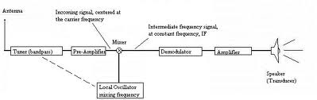

Fig.1 Block diagram of Superheterodyne receiver
The word heterodyne stands for mixing. Here we have mixed the incoming signal frequency with the local oscillator frequency. Therefore this receiver is called superheterodyne receiver. In a superheterodyne receiver, a constant frequency difference is maintained between the local oscillator signal frequency and incoming RF signals frequency through capacitance tuning in which the capacitance are ganged together and operated by a common control know. The intermediate frequency (I.F) amplifier generally contains a number of transformers each consisting of a pair of mutually coupled tuned circuits. Thus, with this large number of double tuned circuits, operating at a specially chosen frequency, the IF amplifier provides most of the gain (sensitivity) and bandwidth requirements (selectivity) of the receiver. This means that the IF amplifier determines the sensitivity and selectivity of the superheterodyne receiver. Also since the characteristics of IF amplifier are independent of the incoming frequency to which the receiver is tuned, the selectivity and the sensitivity of the superheterodyne receiver are quite uniform thought its tuning rage and not subject to variations. Further since, the IF amplifier works at a fixed IF frequency, the design of this system is quite easy to provide high gain and constant bandwidth. Because of its narrow bandwidth, the I.F amplifier rejects all other frequencies except the intermediate frequency. Actually, this rejection process reduces the risk of interference from other stations or sources. In fact, this selection process is the key to superheterodyne receiver’s exceptional performance. After the IF amplifier, the signal is applied at the input of demodulator which extracts the original modulating signal (i.e. audio signal)/ This audio signal is amplified by an audio amplifier to get a particular voltage lever. This amplified audio signal is further amplified by a power amplifier to get a specified power level so that it may activate the loudspeaker. The loudspeaker is a transducer.
However, a superheterodyne receiver suffers from a major drawback known as Image Frequency problem. This problem of image frequency is inherent to a superheterodyne receiver and arises because of the use of heterodyne principle. In fact, the frequency conversion processes carried out by the local oscillator and the mixer often allows an undesired frequency in addition to the desired incoming frequency. In a standard broadcast receiver, the local oscillator frequency is always made higher than the incoming signal frequency. It is kept equal to the signal frequency plus the intermediate frequency (IF). Mathematically,
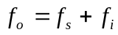 1
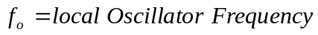
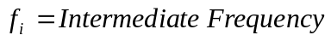
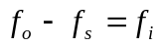 2
Hence, the intermediate frequency (I.F) is the difference between the local oscillator frequency and the signal frequency (R.F). Now, if some frequency 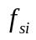manages to reach the mixer such that
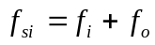 3
Using equation 1 and 3 we get
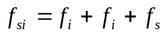 4
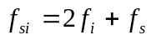 5
Thus this spurious frequency signal cannot be distinguished by I.F stage and hence would be treated same as the desired frequency signal. The rejection of an image frequency signal by a single tuned circuit may be defined as the ratio of the gain at the signal frequency to the gain at the image frequency. This is defined mathematically as
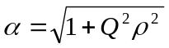 6
Where,
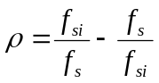 7
And Q is the quality factor which is defined as
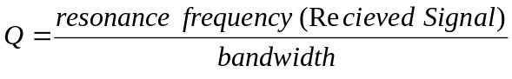
If the receiver has an RF stage, then there is only a single tuned circuit and the rejection is calculated using Eq.6. However, if the receiver has an RF stage then there are two tuned circuits both tuned to f_{s}. The image frequency rejection of each stage will be calculated by using Eq.6. The total or overall rejection will be the product of the two. The image frequency rejection of the receiver depends upon the front end selectivity of the receiver. The rejection of image frequency must be achieved before the I.F stage. Once an undesired or spurious frequency enters the first I.F. amplifier, it would become impossible to remove it from the desired signal. It may be observed that if 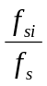is large as is the case of for AM broadcast band the use of an RF stage is not necessary for good image frequency rejection. However, it would become essential above about 3MHz.

MethodS

Equipment List
Computer with MATLAB and SIMULINK installed in it.

Experimental Procedure
For the given R.F. of 780 Hz and I.F. of 335 Hz, the local oscillator frequency (f_{o}) is 1115 Hz (335Hz+980Hz), image frequency (f_{si}) is 1490 Hz (780Hz+2(355)Hz) for value of Q = 90 the image frequency rejection is given by Eq.6 which comes out to be 124.81299.

Results

Conclusions

References
- Leon w. Couch, II, “Digital and Analog Communication Systems”, Sampling Theorem, pp. 87-90,2007.

